V GORIČANI

MEDJIMURJE, CROATIA

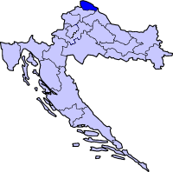

This dance and song is from the region of Medjimurje from village of Goričani. During the Austro-Hungarian occupation of this area, people were prohibited from maintaining their customs and dances. For this reason, solo singing became the only outlet for preserving the culture. Following WW II, those songs were used to a foundation for the creation of many new national dances, rooted in the peasant dances of other bordering cultures. Singing and orchestras comprised of cymbal, violin, clarinet and bass, and the tamburitza orchestra accompanies dances.

*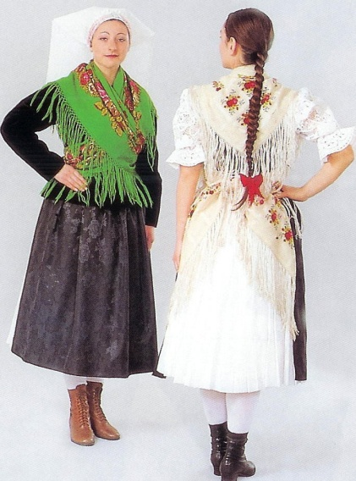Željko Jergan did research throughout the Medjimurje region from 1972 until present days.*

**TRANSLATION:** In the Village of Goričani

**PRONUNCIATION:** VGOH- ree-CHAH-nee *or* GOH- ree-CHAH-nee

**CD:** **“BAŠTINA HRVATSKOG SELA”** by Otrov, Band # 7

**FORMATION:** Cpls face ctr (W on M R side) in a closed circle. If two

W can dance together, they both dance W parts.

**HANDS:** Middle finger hold: Joined in "W" pos.

Hands on hips:

M: Slightly fwd on the hipbone with fingers fwd,

hand at 45 degree angle, elbows slightly fwd.

W: On the waist with fingers fwd, hands parallel to

the floor, elbows fwd.

Shldr. shldr-blade pos:

M: ML hand on WR upper arm, and R hand on shldr blade.

W: WR hand on ML shldr, and L hand on MR upper arm.

**STEPS:** Fig. 1 – Walks, chugs, couple turn

Fig. 2 – Step-hops, runs, turns

**STYLE:** Fig. 1 - Bouncy with fluid knees. Hands move up and down with body when in closed circle formation.

Fig. 2 - Strong and flatfooted with heavy accent.

-------------------------------------------------------------------------------------------------------------------------

**METER:** 4/4 ***PATTERN***

-------------------------------------------------------------------------------------------------------------------------

Meas.

**INTRODUCTION***:* 4 meas.

***Fig. 1*** *(Instrumental)*

***Cpls (W on M R side) in a closed circle with middle fingers joined in “W” pos.***

**Walks**

1 Facing R of ctr and moving in LOD (R), walk R, L, R fwd (cts 1-3); hop on R as L lifts slightly fwd and low - turning to face L of ctr (ct 4).

2 Repeat meas. 1 with opp ftwk and direction. End facing ctr. (LRL-hop in RLOD)

3 Facing and moving twd ctr, walk R, L, R - hop (cts 1-4).

4 Facing ctr and moving bkwd away from ctr, walk L, R, L – hop (cts 1-4).

###### Goričani, Page 2 of 2

**Chugs**

5-6 Facing ctr and dancing in place with *hands on hips* - step R slightly fwd with accent (heavy) with bent knees (ct 1); chug bkwd on R (straighten knee) as L lifts slightly fwd and low (ct 2); repeat 3 more times alternating ftwk (4 in all) (cts 3-4; 1-2, 3-4).

Cue: Beg R do 4 step-chugs. On the last chug turn toward partner.

*Note: keep feet under body; don’t flick free foot fwd or bkwd.*

**Couple turn**

7-8 Cpls turn 1/4 (MR-WL) to face ptr and join in *shldr/shldr-blade pos*. Do 3 buzz – stamp steps, beg R across L, accenting R turning CW (cts 1,&,2,&,3,&); plus R, L to open and facing center (cts 4,&).

*Note: single women just turn in place.*

***Fig. 2*** *(Vocal)*

***Cpls facing ctr in a closed circle with hands joined "V" pos.***

**Step-hops**

1 Chug to R on both feet in place (ct 1); hop on R as L lifts low in front of R (ct 2); repeat cts 1& 2 with opp ftwk (cts 3 & 4). (L-hop, R-hop)

*Note: Steps are heavy and done with an accent.*

2 Facing ctr and moving bkwd away from ctr, walk R, L, R, hop (cts 1-4).

* 1. Repeat meas.1-2 with opp ftwk (L-hop, R-hop, LRL-hop) & direction (twd ctr)

**\*\*\* *Release hands, hands on hips.***

5 **M** Facing and moving twd ctr - walk R, L, R (cts 1-3); hop, clapping hands

and turning half CW (ct 4).Clap hands so that L hand moves above

head ht as R hand moves down to waist level.

**W** R,L,R-hop (cts 1-4), ending with half turn CW. Last pos: back to the ctr.

1. **M** Walk L,R,L away from the ctr facing out (cts 1-3); L, hop clapping

hands and turning half CCW (ct 4). Last pos, L shoulder to the ctr.

**W** Walk L,R,L,hop (cts 1-4) ending with half turn CW. Last pos:face to ctr.

7-8 **M** Meas. 7: Stamp with R (cts 1 & 2); stamp with R again (cts 3 & 4).

Meas. 8: Clap hands Q, Q, S and pause (cts 1-4).

**W** 2 turns CW in place: 3 buzz/stamp steps and step R, L walk to end facing ctr. *Note: On claps, M shoulders back slightly.*

🟓***PATTERN:******Fig. I - II*** / 4 times

*V Goričani širke gače nosiju. V Goričani velko blato po polju,*

*V Domanšinci v zimi repu prosiju. Naj se Štefek tam ženiti k nikomu.*

*Dečki trepaste škrljake imaju, Ne mine mi denek niti vurica,*

*Širke šurce pak se ž jimi štimaju. Kaj se ne bi zmislil za te rožica.*

In the village of Goričani, boys are wearing very wide pants.

Boys proudly wear black hats.

In the village of Goričani, there is a lot of mud in the fields,

Don’t get married there Steven; not to anyone

Every day and every moment, I have my love on my mind.



##### Dance notes by Željko Jergan and Fusae Senzaki, 7-04